
Faculty of Computing Universiti Teknologi Malaysia

PSM 2 (SEC_ 4134)
REPORT CORRECTION AND RESUBMISSION FORM

Session/Semester:
Instruction: [Student] - Please submit a completed form to the PSM2 Department Coordinator.

SECTION A: Student and project info

Name: ABDUL AZIM BIN ANUAR VEERA
Project Title: COMPARATIVE STUDY OF BIO-INSPIRED OPTIMIZATION ALGORITHMS
FOR FEATURE SELECTION IN INTRUSION DETECTION SYSTEM
Supervisor: ASSOC. PROF. DR. ANAZIDA BINTI ZAINAL
Project Type: Research | Matric. No.: A21EC0001
E-mail Add.: azim02@graduate.utm.my | No. Tel/HP: 010-7774830
Examiner 1 Name: TS. DR. MOHD ZAMRI  BIN OSMAN | Examiner 2 Name: DR. MOHD KUFAISAL  BIN MOHD SIDIK
Date: 17/7/2025 | 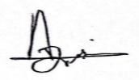  Signature:

SECTION B: Examiners and Supervisor Declaration
**Note: Please note that endorsement from ALL parties is required before report/thesis is accepted for completion.

Examiner 1 Declaration
I, Ts. Dr. Mohd Zamri bin Osman, certify that I have reviewed the correction of the Project Report of the abovementioned student. I endorse that it is complete.

Signature: Official Stamp
22.07.2025
Date:

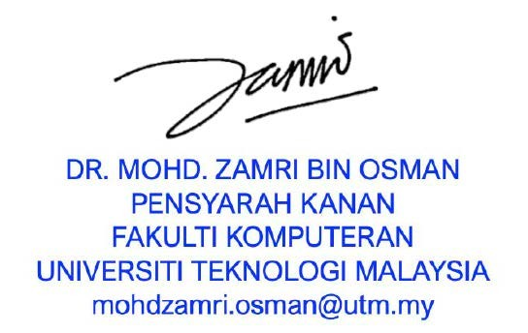
Examiner 2 Declaration

I, Dr. Mohd Kufaisal Bin Mohd Sidik, certify that I have reviewed the correction of the Project Report of the above-mentioned student. I endorse that it is complete.
21/7/2025

Date:
Signature: Official Stamp
- Supervisor Certification


I, Assoc. Prof. Dr. Anazida Binti Zainal, declare that I have accepted and reviewed the Project Report Correction and endorsed to its completion. I have also accepted and reviewed the Log Book of the abovementioned student.
DR. MOHD KUFAISAL BIN MOHD SIDIK
Senior Lecturer Department of Computer Science
Faculty of Computing Universiti Teknologi Malaysia
Signature: Official Stamp
20 July 2025
Date:

